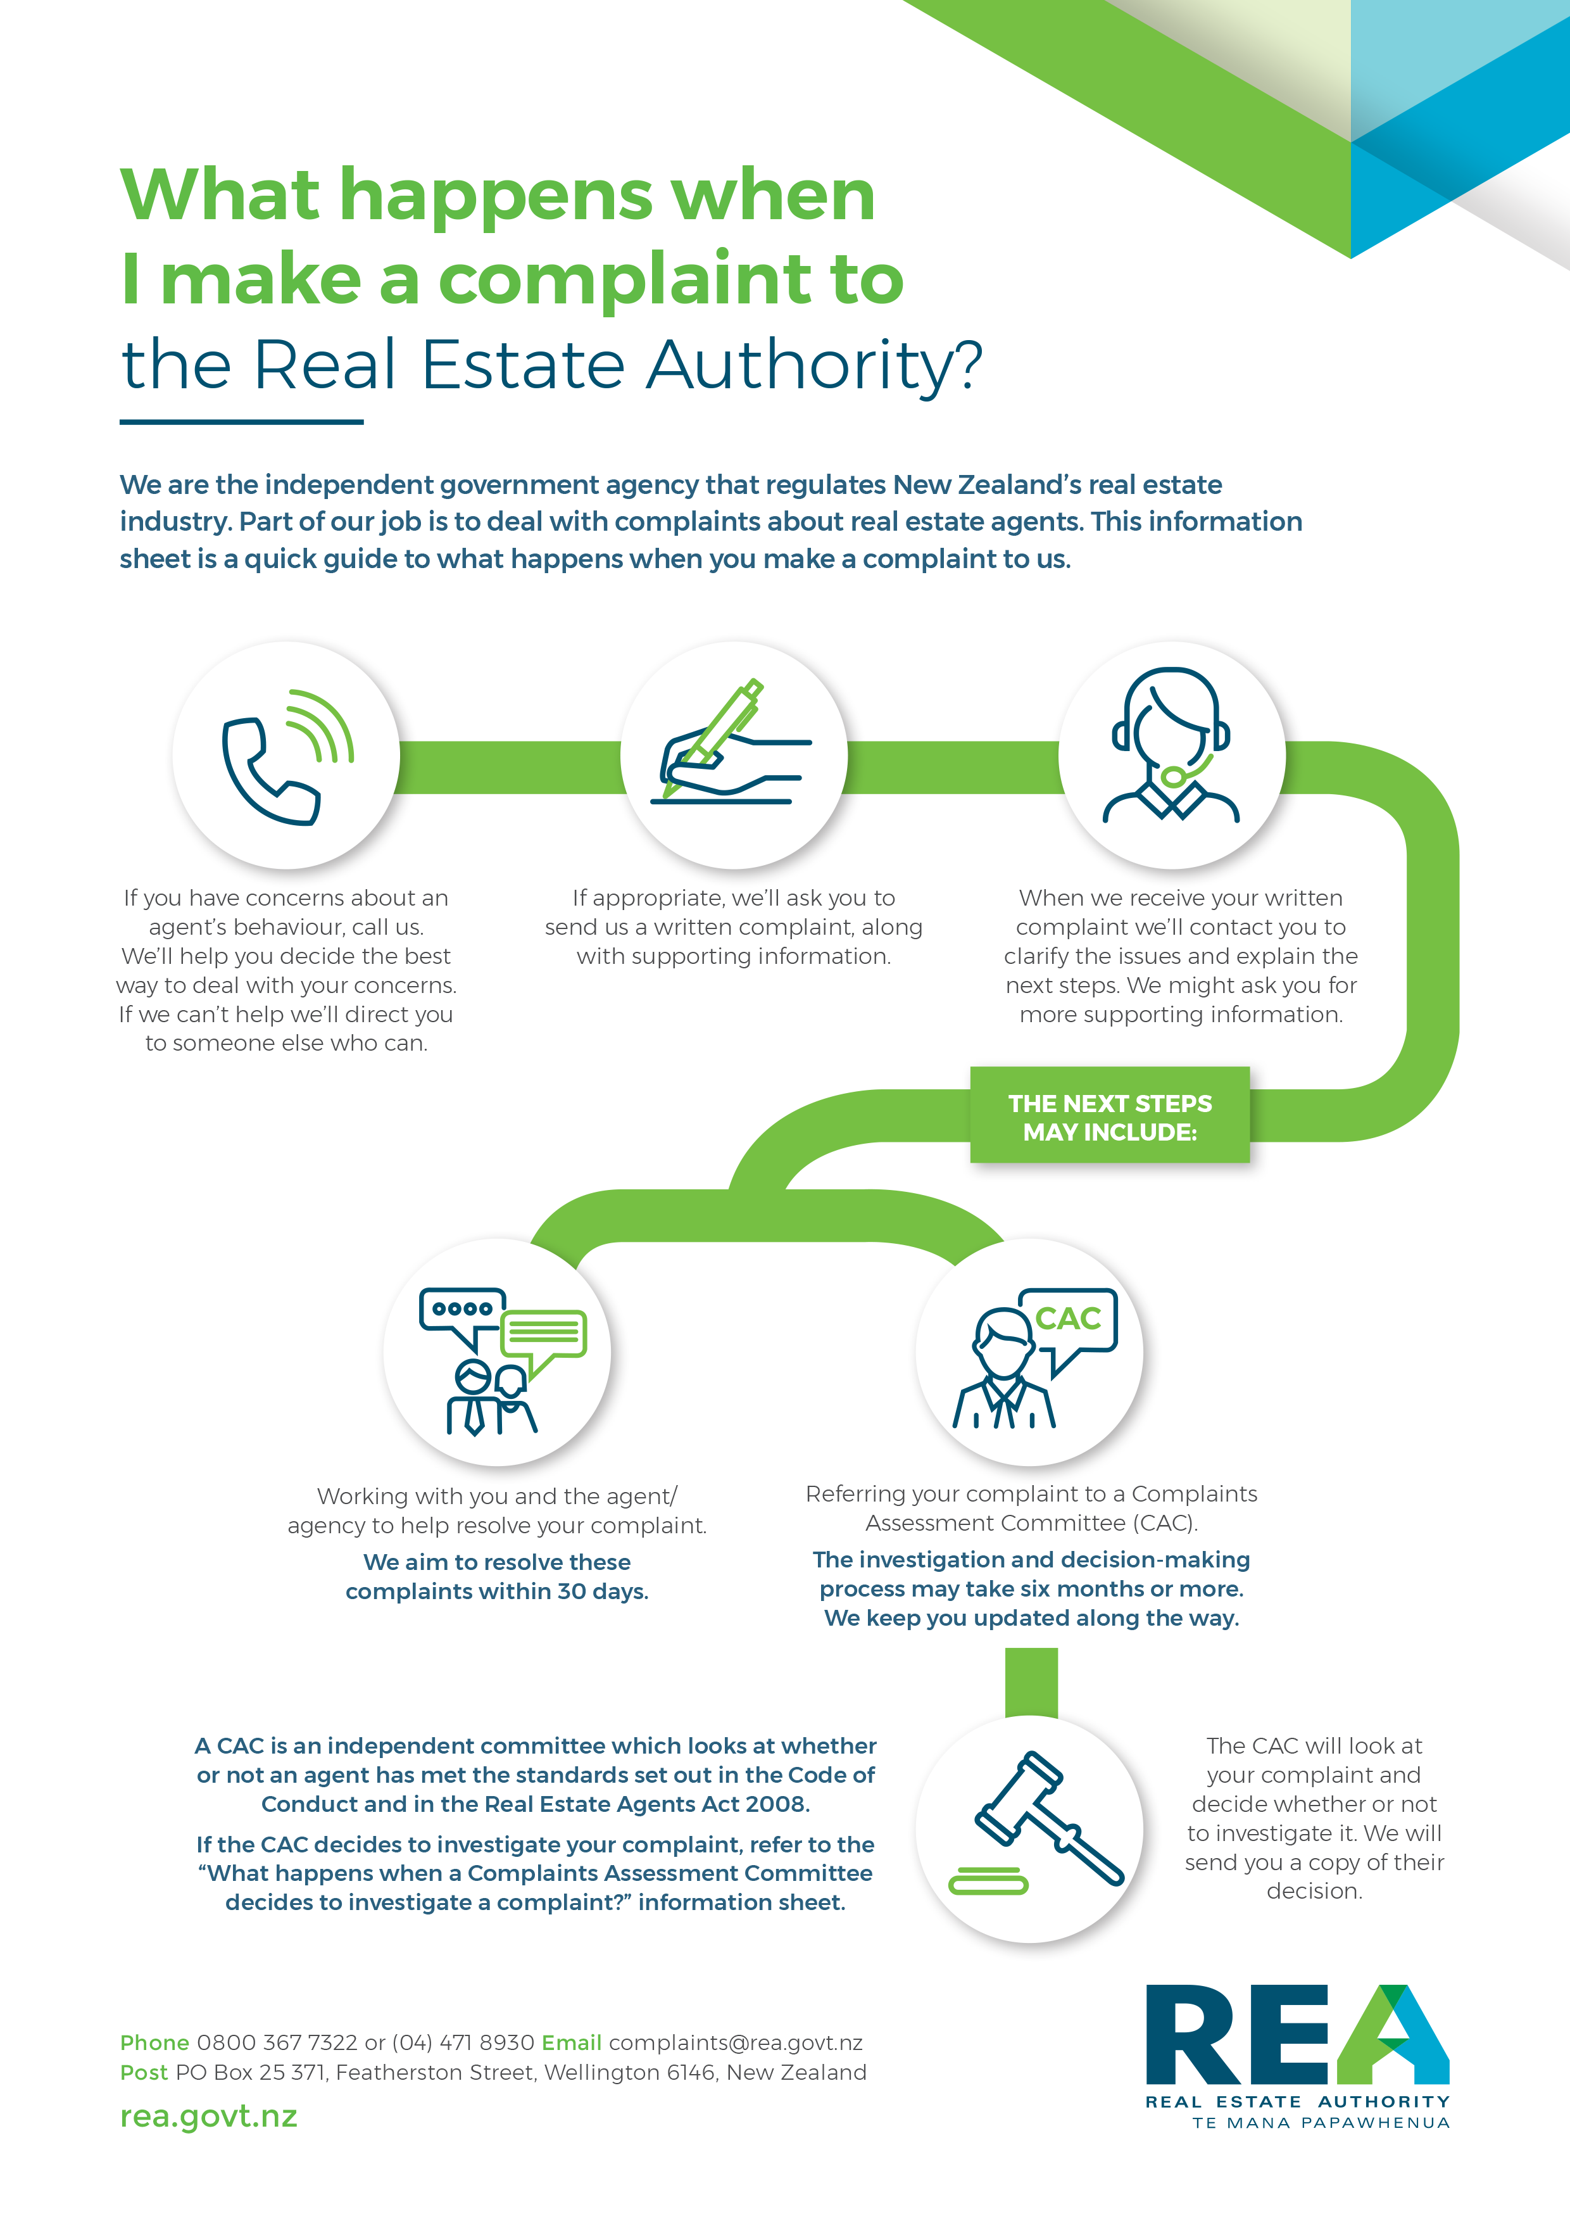
Make a
complaint
Use this form to make a complaint about a real estate salesperson, agent, or agency —
even if they’re no longer working in real estate.
Before you start
Talk to the person or agency involved
Sometimes you can avoid making a complaint by talking things through with whoever’s involved.
Call us
If the problem’s still not fixed, call us on 0800 367 7322 to make sure your complaint is one we can help with. For example, we can’t help with most complaints about residential property management.
Collect all the details and evidence
We can only help with your complaint if we have all the details. We’ll need your contact details, a full explanation of what you’re not satisfied with, and any documents that support your complaint.
Know that the person or agency involved may see your complaint
To help resolve your complaint, we may send the details (and any supporting documents) to the person or agency you’re making a complaint about. We may pass on your postal address but not your phone number or email address.

Details of you and anyone else making the complaint
You can make your complaint alone, with another person, or on behalf of another person.
Mr Mrs Miss Ms Other
Full name
Preferred name
Daytime phone
Alternative phone
Email
Postal address
Town or city
Postcode
Ethnicity*
Mr Mrs Miss Ms Other
Full name
Preferred name
Daytime phone
Alternative phone
Email
Postal address
Town or city
Postcode
Ethnicity*
* We collect information about your ethnicity to better understand who’s having problems with real estate professionals.
In relation to this complaint, are you (or were):
selling a property
buying a property
hoping to buy a property
a real estate agent
other (please explain)
If you’re making this complaint on behalf of someone else
Please tell us:
Their full name
Their daytime phone
Please explain why you’re making this complaint for them.

Details of the person, people, or agency you’re complaining about

Full name
Agency name
Phone
Email
Full name
Agency name
Phone
Email

Details of anyone who can support your complaint
Please provide details of anyone who may be able to provide further evidence. For example, a family member, a lawyer, a builder, or another real estate agent. We won’t pass on their contact details to the agent or agency.

NAME | CONTACT DETAILS

Details of your complaint
Please provide as much information as you can.
Address of the property involved in the complaint

Explanation of what happened
Explain in detail what the person or agency did that you’re not satisfied with. Include dates or a timeline of events so we can understand exactly what happened and in what order.

Summary of the issues
Summarise the issues you have with the way the person or agency behaved.

Documents to support your complaint
Please send us any documents that support your complaint. If you do not send them with this form you may not have another opportunity during the complaint process.
What documents are you sending?
Agency agreement
Sale and purchase agreement
Certificate of Title
Correspondence with the person or agency
Valuation
Advertising
Land Information Memorandum (LIM)
Appraisal
Builder’s report
The agency’s response to your complaint
Other
What you’ve already done to sort the problem out
Have you contacted the REA about this complaint before?
Yes
No
Have you discussed your complaint with the person or agency involved?
Yes
No
If yes, please explain what happened when you discussed it with the person or agency.

Is any another organisation (for example, the Disputes Tribunal) dealing with this complaint, or have they already dealt with it?
Yes
No
If yes, please send us a copy of the details.
What you’d like to happen
Please explain what you’d like to happen to resolve this complaint.
What you agree to when you send us this form
You agree to all the following things.
• We can send details of your complaint and any supporting documents to the person or agency you’re making a complaint about (but we won’t pass on your contact information).
• We can email you (at the address you’ve provided) any information or decisions about this complaint.
• All the information you’ve provided is true and correct.
Your name
Your signature (if you’re posting this form)
Date
Where to send this form and supporting documents
Please send your completed form and documents to either:
• complaints@rea.govt.nz
• PO Box 25 371, Featherston Street, Wellington.
Before you send us your complaint, please check you have:
called us on 0800 367 7322 to discuss the complaint
provided your contact details, including your phone number
enclosed or attached any documents that support your complaint.
We’ll hold your personal information in line with our privacy policy. You can find this policy on our website — rea.govt.nz — or you can call us to ask for a copy.

